1. **INTRODUCTION**

1.1 Overview

**Project Description:**

* The banking industry world-wide is being transformed. The global forces for change include technological innovation; the deregulation of financial services at the national level and opening-up to international competition; and - equally important - changes in corporate behavior, such as growing disintermediation and increased emphasis on shareholder value. In addition, recent banking crises in Asia and Latin America have accentuated these pressures. The banking industries in central Europe and Latin America have also been transformed as a result of privatizations of state-owned banks that had dominated their banking systems in the past. In this project we are trying to analysis the bank related data and able to extract some insights from the data using Business Intelligence tools. To Extract the Insights from the data and put the data in the form of visualizations, Dashboards and Story we employed Tableau tool.
  1. Purpose

Tableau **helps people and organizations be more data-drive** As the market-leading choice for modern business intelligence, our analytics platform makes it easier for people to explore and manage data, and faster to discover and share insights that can change businesses and the world

Everything we do is driven by our mission to help people see and understand data, which is why our products are designed to put the user first—whether they’re an analyst, data scientist, student, teacher, executive, or business user. From connection through collaboration, Tableau is the most powerful, secure, and flexible end-to-end analytics platform.

**2 RESULT**

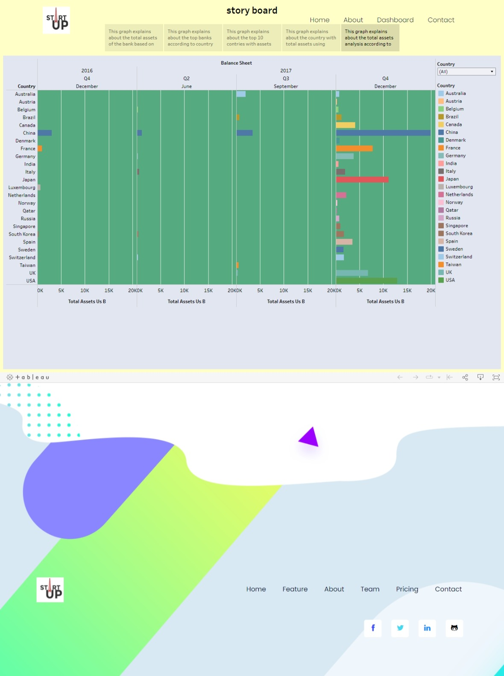

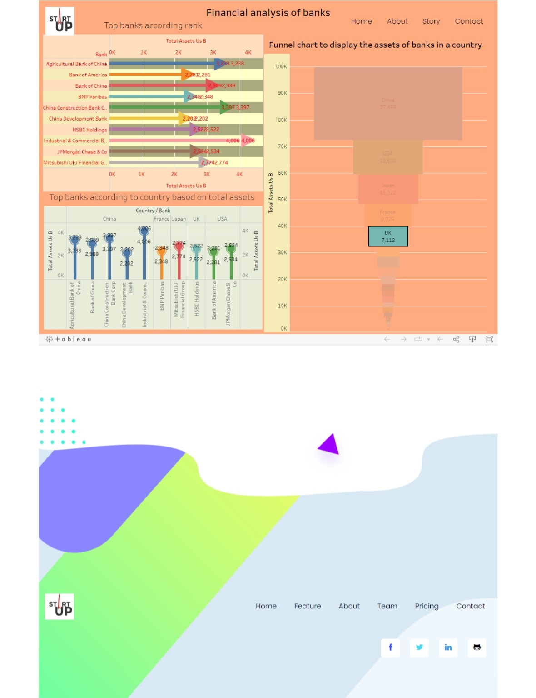

# 3 Advantages and Disadvantages

**Should You Invest in Tableau?**

If you’re reading this article you are probably wondering if you should be investing your hard-earned dollars or your company’s dollars on Tableau. So, I’ve broken out the advantages and disadvantages of Tableau. Without, a doubt, Tableau is the leader in the data viz space.  However,  there are some limitations that may point you towards another tool.  There are a lot of alternatives out there if you compare to Power BI or Qlikview. Check out our comparison article on [4 Tableau Alternatives.](https://absentdata.com/tableau-alternatives/)

**Reasons to Invest:**

**Advantages of Tableau**

[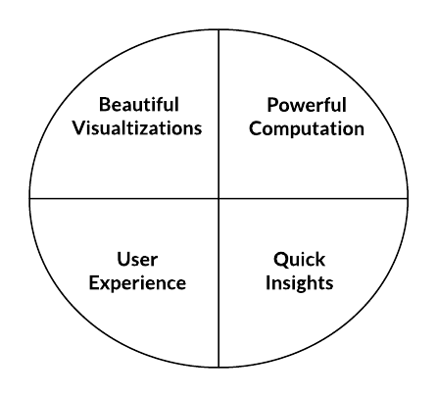](https://i0.wp.com/absentdata.com/wp-content/uploads/2017/11/Blank-Diagram-Page-1-2.png?ssl=1)

1. **Data visualization**  
Tableau is a data visualization tool first and foremost. Therefore, it’s technology is there to support complex computations, data blending and dashboarding for the purpose of creating beautiful visualizations that deliver insights that cannot easily be derived from staring at a spreadsheet. It has climbed to the top of the data visualization heap because of it’s dedication to this purpose

2.  **Quickly Create Interactive visualizations:**  
Using drag-n-drop functionalities of Tableau, the user can create a very interactive visual within minutes. The interface can handle endless variations while also limiting you from creating charts that are against data visualization best practices. You can check out some of the amazing visuals created at the [Tableau Gallery.](https://public.tableau.com/en-us/s/gallery)

**3. Ease of Implementation:**  
There are many different types of visualization options available in Tableau which enhance the user experience. Also, Tableau is very easy to learn compared to Python, Business Objects and Domo, anyone without having knowledge of coding can easily learn Tableau.

**4. Tableau can handle large amounts of data:**  
Tableau can handle millions of rows of data with ease. Different types of visualization can be created with a large amount of data without impacting the performance of the dashboards. Also, there is an option in Tableau where the user can make “live” to connections to different data sources like SQL etc.

**5. Use of other scripting languages in Tableau:**  
To avoid the performance issues and to do complex table calculations in Tableau, users can incorporate  Python or R. Using Python script can take the load off the software by performing data cleansing tasks with packages. However, Python is not a native scripting language accepting by Tableau. So you can import some of the visuals or packages. However, you can see how this is down with [Python for Power BI.](https://absentdata.com/how-to-user-python-and-power-bi/)

**6. Mobile Support and Responsive Dashboard:**

Tableau Dashboard has a great reporting feature that allows you to customize dashboard specifically for a certain device such as a mobile phone or laptop. Tableau automatically understands which device is the user is viewing the report on and make adjustments to ensure that the right report is served to the right device.

**7. Tableau Company Strategy:**

Tableau has done a great job climb its way to the top of data visualization tools. So,  according to [Garner Magic Quadrant](https://www.gartner.com/en/research/methodologies/magic-quadrants-research). Tableau has spent more than six years as a  leader. However, with the increasing interest in data science, artificial intelligence, and machine learning, Tableau may be left behind if it doesn’t innovate quickly.  You can see from the issues with 2017 financials reporting [Forbes concerns with Tableau profitability](https://www.forbes.com/sites/greatspeculations/2017/03/20/tableau-software-fundamentals-fail-to-justify-stock-price/#4b56543115eb)

**Reasons to Not Invest:**

**Disadvantages to Tableau**

So, now that you know all the great aspects of the tool, lets dive into some of the more challenging aspects of it. The section below is going to highlight some of the pain points that many Tableau users express.

[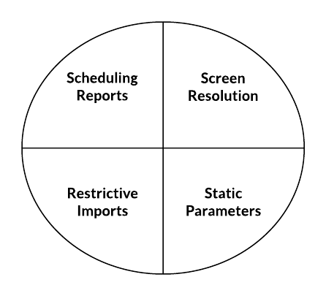](https://i0.wp.com/absentdata.com/wp-content/uploads/2017/11/Blank-Diagram-Page-1-3.png?ssl=1)

**1. Scheduling or notification of reports:**  
Tableau does not provide the feature of automatic refreshing of the reports with the help of scheduling. There is no option of scheduling in Tableau. Therefore, there is always some manual effort required when users need to update the data in the back-end.

**2. No Custom Visual Imports**  
Tableau is not a complete open tool. Unlike other tools like Power BI, developers can create custom visuals that can be easily imported Tableau. So, any new visuals need to be recreated instead of imported.

**3. Custom formatting in Tableau:**  
Tableau’s conditional formatting and limited 16 column table displays are pain points for users. Also, to implement the same formatting to multiple fields there is no way a user can do that for all fields directly. Users need to do that manually for each field which is very time-consuming.

**4 APPLICATIONS**

Usage of Tableau software are listed below:

* Business Intelligence
* Data Visualization
* [Data Blending](https://intellipaat.com/blog/tutorial/tableau-tutorial/data-blending-tableau/)
* Data Collaboration
* Query translation into visualization
* To create no-code data queries
* Real-time data analysis
* To manage large size metadata
* To import large size of data

Ever since it was introduced, this data visualization tool is used for the Business Intelligence industry. Organizations like Amazon, Walmart, Accenture, Lenovo, and so on widely use Tableau. Join [Tableau training in London](https://intellipaat.com/tableau-training-london/) and excel in your career!

**5 CONCLUSION**

Conclusion- Tableau Visualization

Tableau is a very effective tool for graphical representation, and it has more than 24 different graphical views to display data. Though the dataset is complex or the dataset is very big, in tableau, we can create dashboards very easily and within less time.